**GROUP 3**

**Macleana Mensah Oteng**

**Elizabeth Wallace Arthur**

**Nick Anderson**

**Eugene Essuman - Quansah**

**Mohammed Razak Mikdar**

**INTRODUCTION**

This report outlines the group’s practical experience with Linux system administration tasks using Oracle VirtualBox. The objective of this task was to explore and apply essential Linux commands and system management tools in a hands-on setting. Using Ubuntu as the base operating system within Virtualbox, we navigated various tasks such as granting access to files and folders in Linux. Each tasks aimed to strengthen our understanding of Linux as a multi-user operating system and to build the skills necessary for effective system maintenance and troubleshooting. Through these tasks, we encountered and resolved real-world issues that system administrators commonly face, enhancing our technical knowledge, teamwork and collaboration as well as problem-solving abilities.

**Task 1: Create a Directory and Files**

1. Create a directory named "my_directory" in your home directory.



**Mkdir** command is used to create directories in linux.

**Ls** command is used to list the content of a directory.

1. Create three files within the directory: file1.txt, file2.txt, and file3.txt.
2. 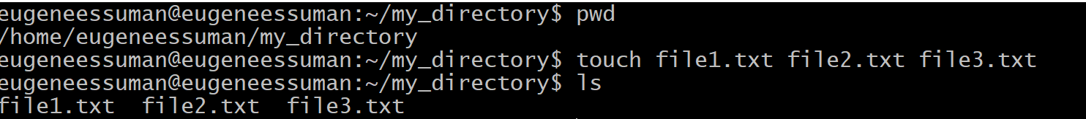
3. **touch** command is used to create files.

**Task 2: Check Default Permissions**

1. Use ls -l to list the files with their permissions.
2. Note the default permissions assigned to the files (e.g., -rw-r--r--).
3. 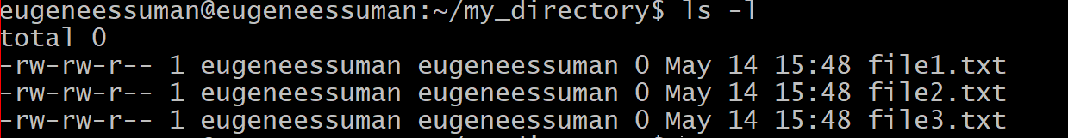

**Ls -l** command is used to list the content of a directory together with their read, write and execute permissions.

**Task 3: Modify Permissions**

1. Change the permissions of file1.txt to read-only for the owner, readable by the group, and executable by others.
2. 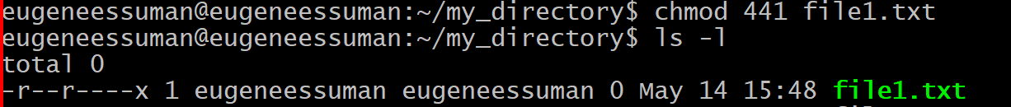
3. **chmod** command is used to assign read, write and execute permissions to a file.
4. **4 – Read** , **2 – Write and Execute – 1.**
5. Make file2.txt readable and writable by the owner and group, but not accessible to others.
6. 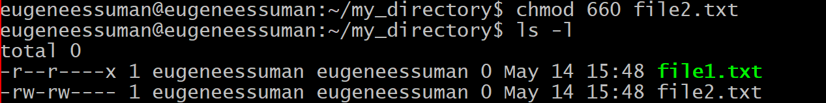
7. Make file3.txt executable for everyone.
8. 

**Task 4: Change Ownership and Group**

1. Change the owner of file1.txt to another user (if available).
2. 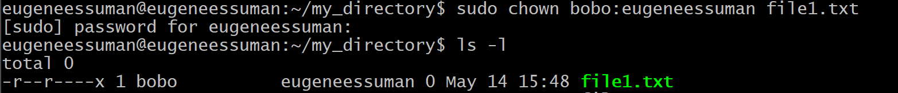
3. **chown** command is used to change ownership of a file.
4. Change the group ownership of file2.txt to a different group.
5. 

**Task 5: Use umask**

1. Set the umask to 0077 and create a new file named file4.txt.
2. Observe the default permissions assigned to file4.txt.

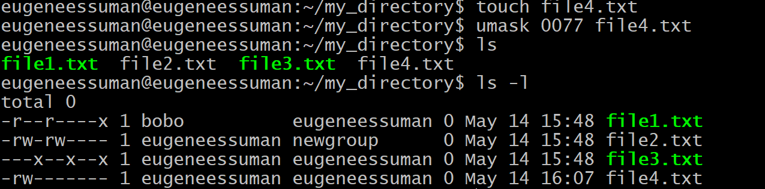

**Umask** command is used to remove permissions from the systems default permissions.

**Task 6: Create a Directory with Specific Permissions**

1. Create a directory named "restricted_dir" with read-only permissions for the owner, group, and others.
2. 
3. Try to create a file within the directory. What happens?
4. 
5. Not possible to cd into a read-only folder. We will need the execute (x) to make changes.

**Task 7: Troubleshoot Permission Issues**

1. Create a scenario where you encounter a permission error (e.g., trying to delete a file you don't have permission to).
2. b. Use ls -l and other commands to diagnose the issue and resolve it
3. 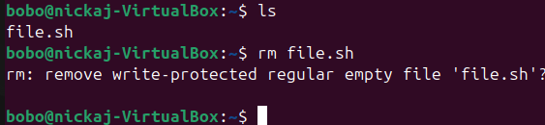
4. We tried deleting a file named **“file.sh”** using the user **bobo** but the system denied us.

So we used the **ls -l** to check the file permissions and ownership and we realized it belonged to another user (**nickaj**) with a sticky bit in the below image.

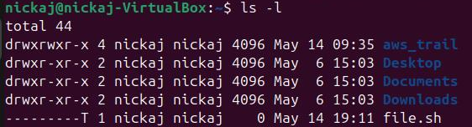

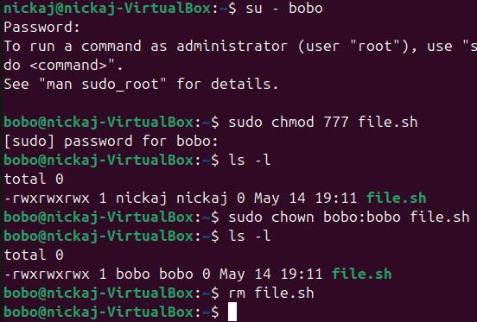

We changed ownership of the file from **nickaj** to **bobo** using the **chown** command and we were able to use the **rm** command to remove the file successfully using **bobo** as shown in the above image.

**Conclusion**

We now have a solid grasp of how to view and change file and directory permissions, the role of ownership and special permission bits, using umask to control defaults and how to diagnose and resolve permission errors.

After completing this assignment, we can troubleshoot access issues confidently.